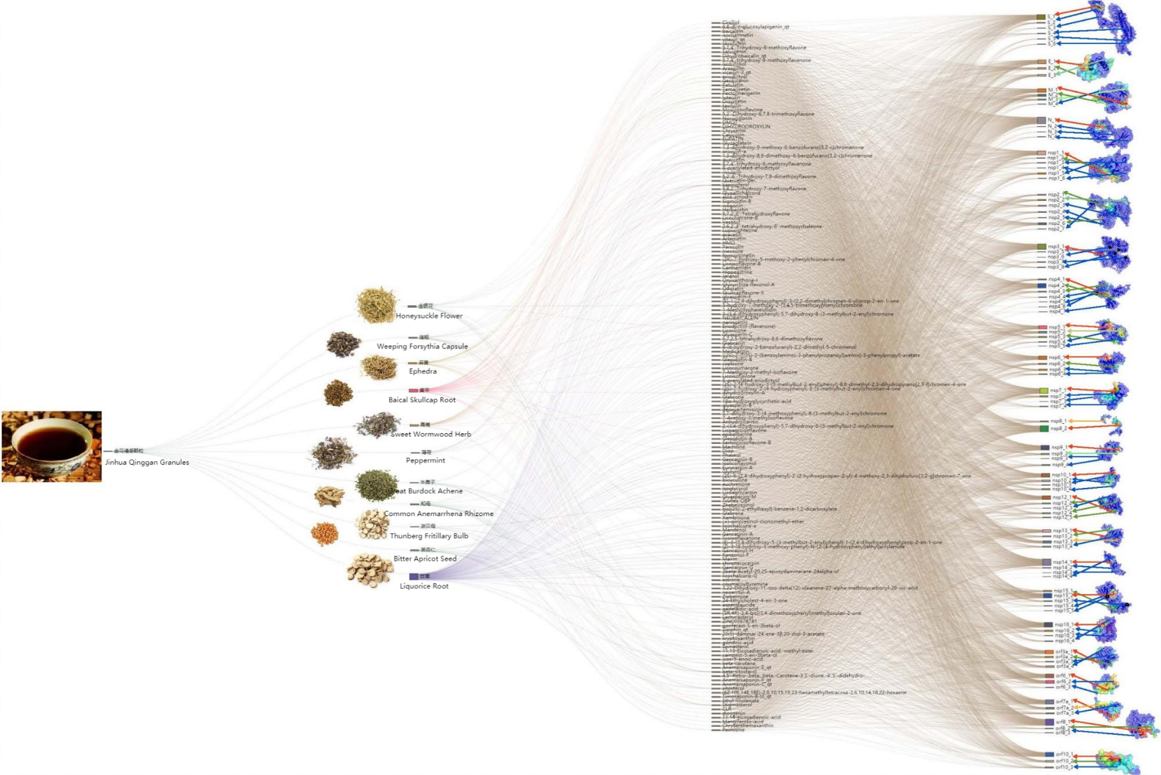

Fig. 1 **Herbs-Compounds-Proteins** docking result for the herbs prescription of Jinhua-Qinggan

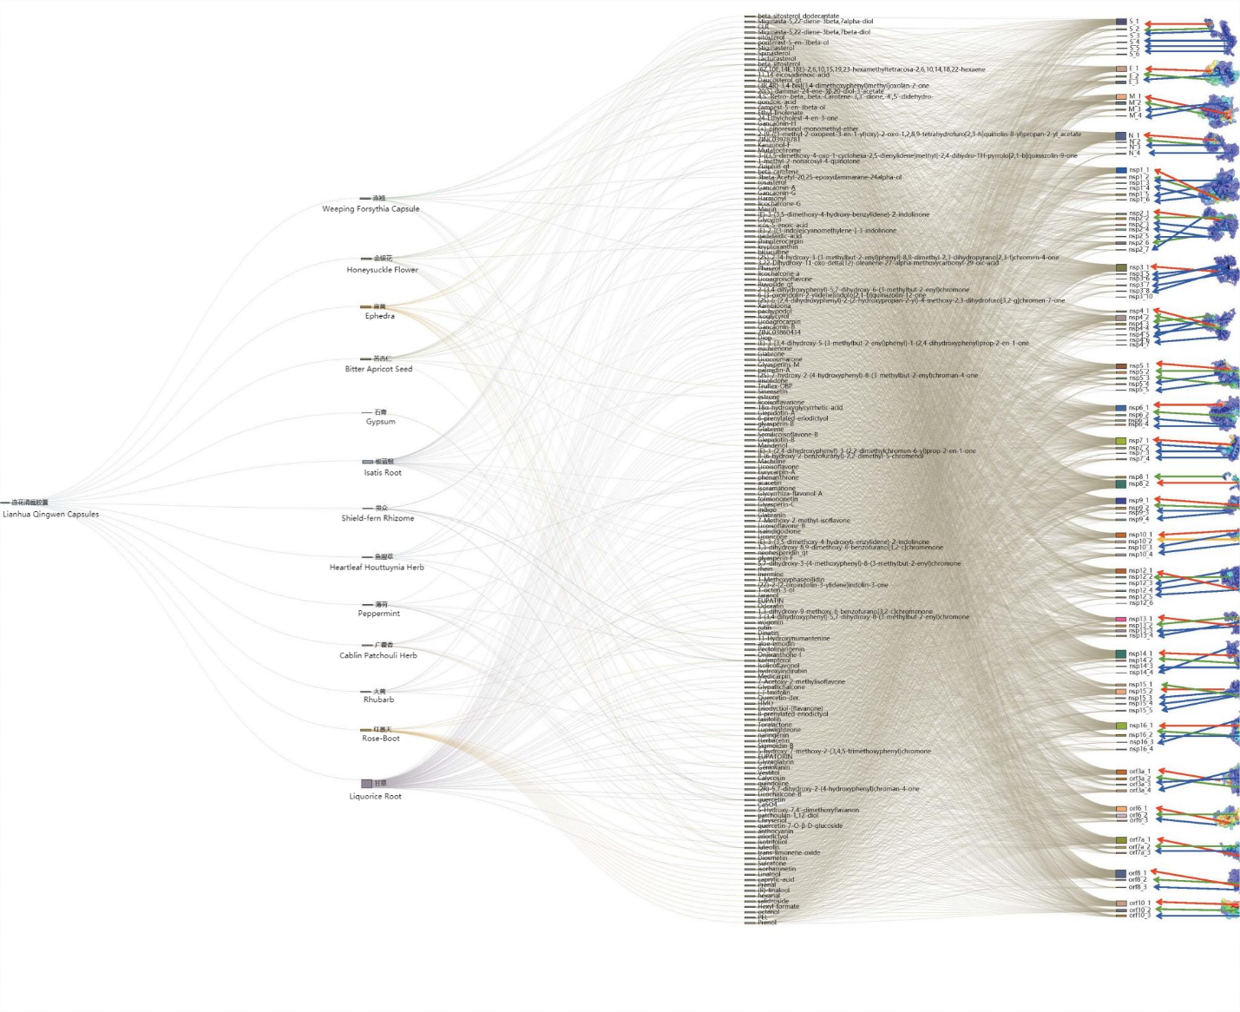

Fig. 2 **Herbs-Compounds-Proteins** docking result for the herbs prescription of Lianhua-Qingwen.

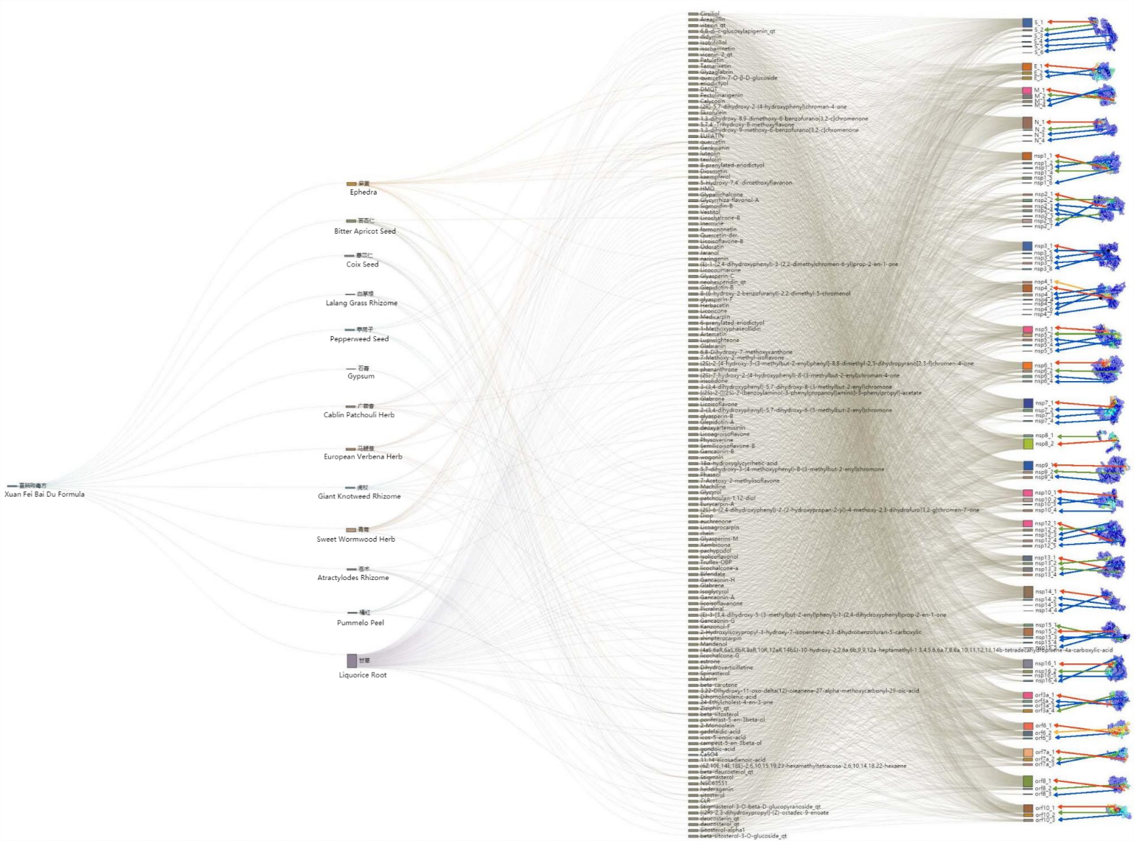

Fig. 3 **Herbs-Compounds-Proteins** docking result for the herbs prescription of Xuanfei-Baidu..

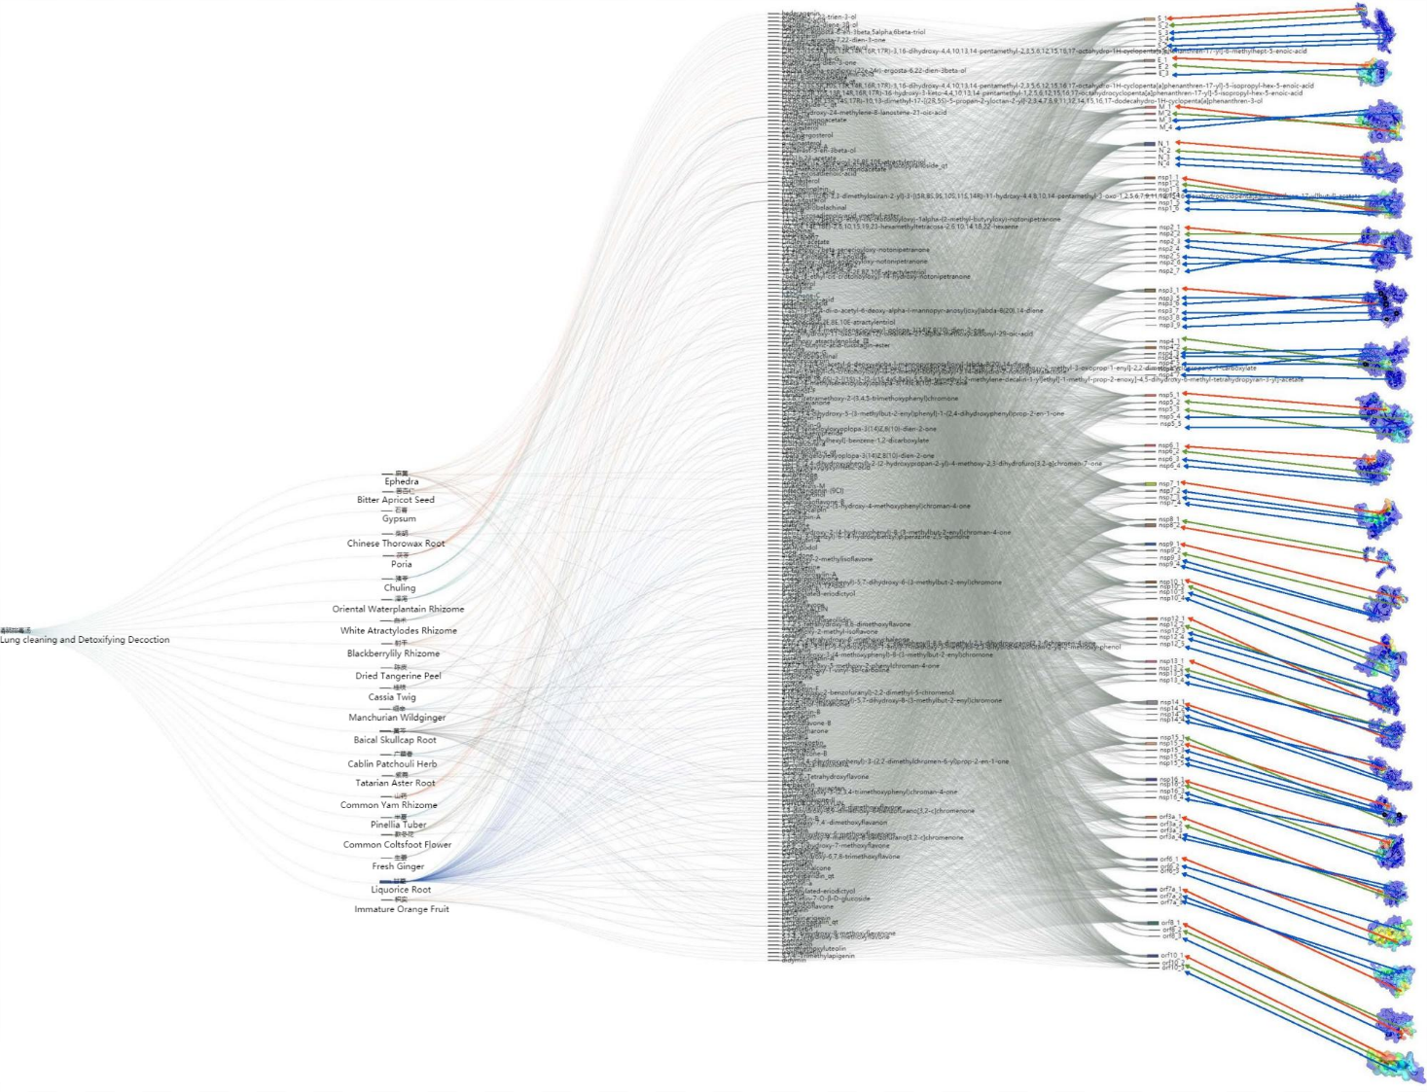

Fig. 4 **Herbs-Compounds-Proteins** docking result for the herbs prescription of Qingfei-Paidu.

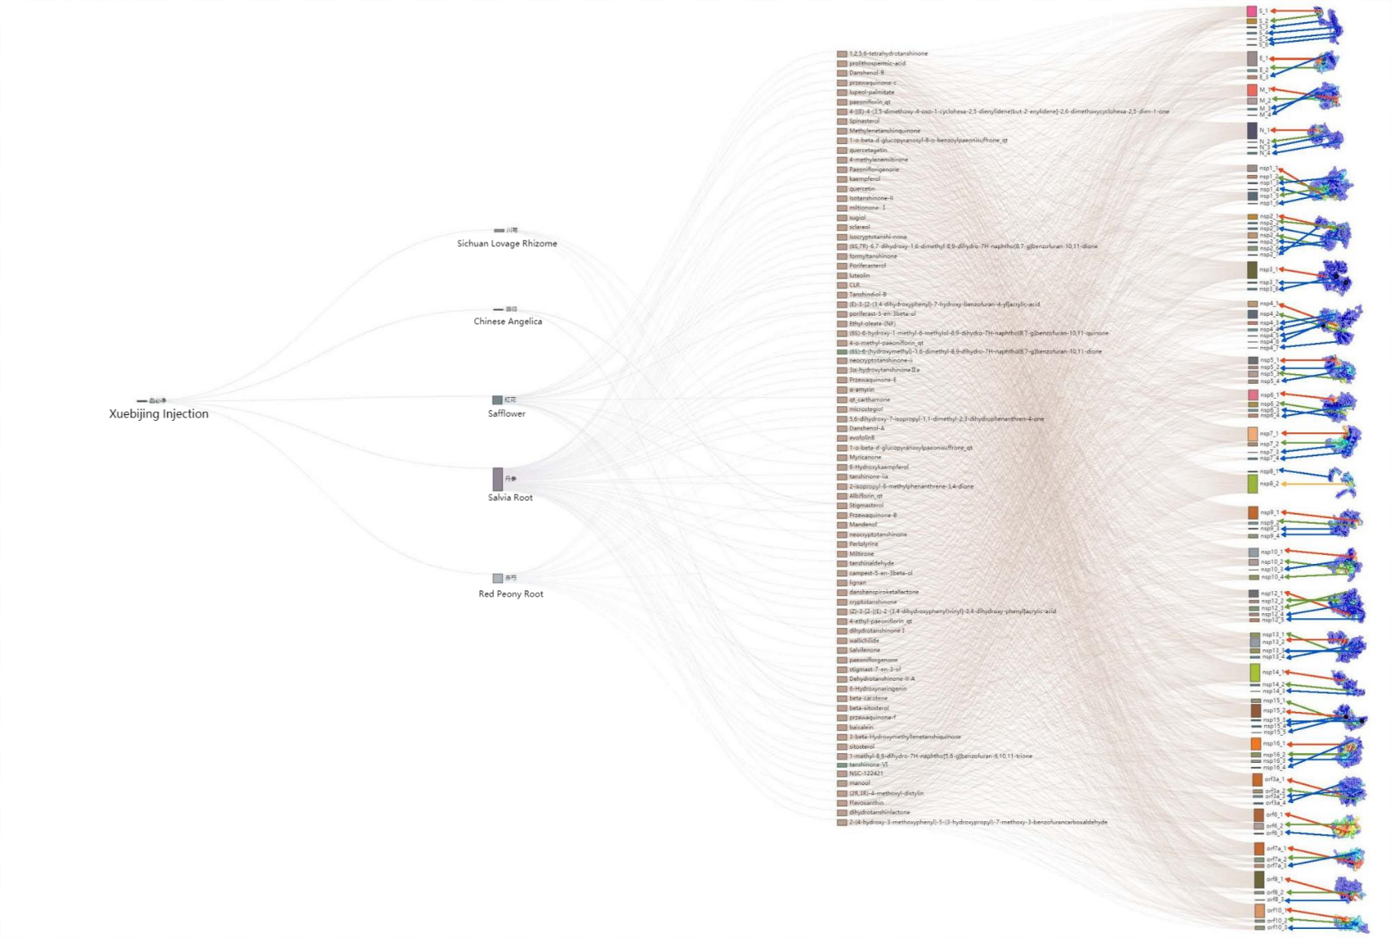

Fig. 5 **Herbs-Compounds-Proteins** docking result for the herbs prescription of Xuebijing.

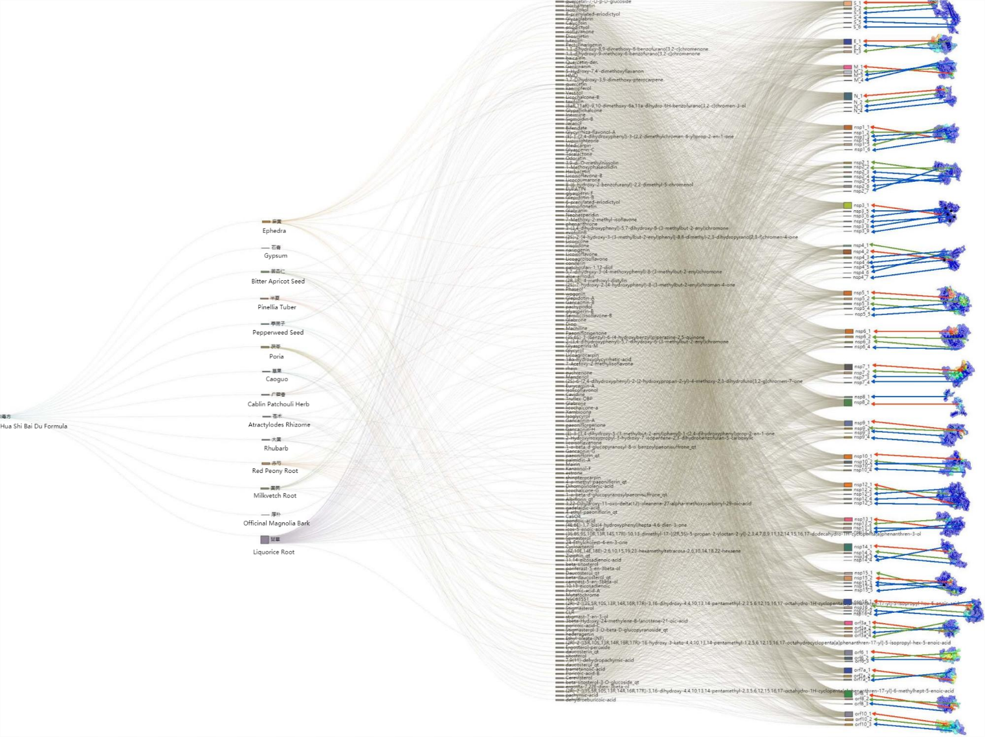

Fig. 6 **Herbs-Compounds-Proteins** docking result for the herbs prescription of Huashi-Baidu.